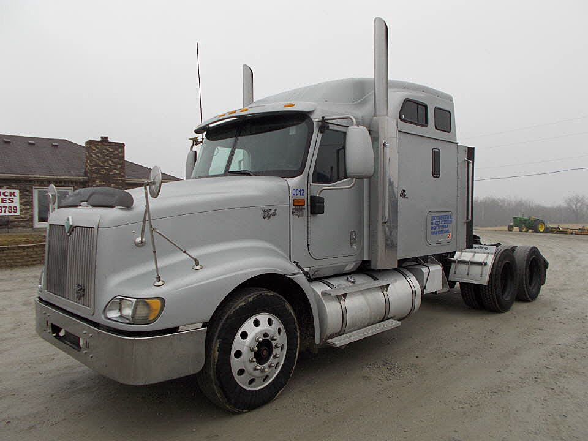
The International 9400i Eagle is an unlockable vehicle in the BEAMNG.drive TAMNG game, which can be unlocked in Ford Challenge mode. The car is a 2-door, heavy-duty pickup truck, built as a concept that was meant to showcase the latest turbo-diesel engine it was equipped with at that time.
In the game, the car has a decent top speed with an average acceleration. However, it has one of the worst handling and is also the heaviest in its class. Therefore, it may struggle to turn properly on sharp turns without braking a lot. Despite that, it is relatively quick and can easily outrun the other opponents on straightaways.

Contents
- 1
- Version Appearances
- 2
- Stats
- 3
- How to Unlock
- 4
- Available Colours
- 5
- Gallery
- 6
- Trivia
- 7
- External Links

Version Appearances
- PC
- PS2
- Xbox

Stats
- Speed: 5
- Handling: 2
- Acceleration: 4
- Weight: 7

How to Unlock
In Ford Challenge mode, complete Concepts Challenge 1 on any difficulty.

Available Colours
- Yellow (Default)
- Light Green
- Teal
- Red

Gallery
The following 27 files are in this category, out of 27 total.
- 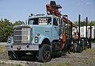
1989 International Eagle F9370 logging truck, front left.jpg5,022 × 3,483; 9.41 MB
- 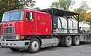
1993 International Eagle 9700 in Red, Front Left, 08-15-2022.jpg3,397 × 2,105; 4.87 MB
- 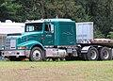
1997 International 9400 Eagle sleeper cab, front left, 08-03-2024.jpg4,479 × 3,226; 3.97 MB
- 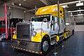
1999 International 9300 Eagle semi trailer. Free image Spielvogel.jpg5,834 × 3,890; 9.81 MB
- 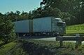
2004 International 9800i (14102088009).jpg4,227 × 2,776; 3.47 MB
- 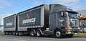
2004 International Eagle 9800i (14646454320).jpg5,220 × 2,478; 2.82 MB
- 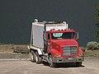
20130720-FS-UNK-003 (9420557865).jpg6,144 × 4,608; 1.9 MB
- 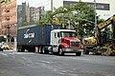
29th St 10h Av td (2018-08-16) 03.jpg5,472 × 3,648; 6.68 MB
- 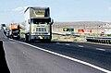
Arizona, Ruta 66 (1989) 02.jpg958 × 633; 458 KB
- 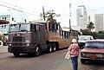
Camel bus in Havana, 2009.jpg800 × 538; 478 KB
- 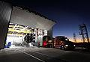
CRS-2 Dragon arrives at hangar.jpg2,900 × 2,000; 803 KB
- 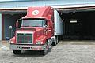
FEMA - 13838 - Photograph by Mark Wolfe taken on 07-12-2005 in Alabama.jpg3,008 × 2,000; 1.51 MB
- 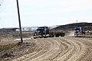
Freight trucks near Iqaluit Airport.JPG5,184 × 3,456; 6.25 MB
- 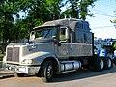
International 9200i Eagle Pro Sleep 1998 (19103262116).jpg2,800 × 2,100; 1.5 MB
- 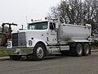
International 9600 Eagle conventional.jpg3,648 × 2,736; 2.2 MB
- 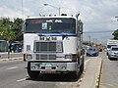
International 9700 - 02 (Jamaica).jpg5,184 × 3,888; 4.97 MB
- 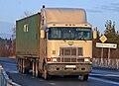
International 9800 (Newport) COE in Russia, 2014.jpg2,309 × 1,669; 2.67 MB
- 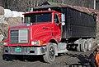
International Eagle farm truck VT.jpg3,228 × 2,214; 3.69 MB
- 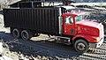
International Eagle farm truck.jpg3,183 × 1,791; 3.62 MB
- 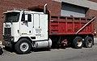
International Newport series COE dump truck.jpg5,268 × 3,312; 8.06 MB
- 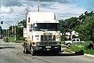
International truck, Harare (11760915654).jpg1,280 × 851; 210 KB
- 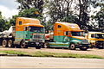
International trucks Harare (11760741683).jpg1,280 × 849; 248 KB
- 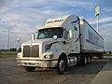
International Wal-Mart Truck.jpg2,592 × 1,944; 1.1 MB
- 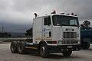
MeyerBeton International Eagle (18708383634).jpg3,392 × 2,248; 2.74 MB
- 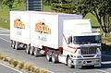
New Zealand Trucks - Flickr - 111 Emergency (117).jpg1,568 × 1,028; 369 KB
- 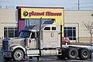
Planet Fitness and sign look like fate stepped in to Women's Trucking Federation.jpg6,000 × 4,000; 6.03 MB
- 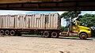
Tractomula en Colombia.jpeg4,128 × 2,322; 3.97 MB

Trivia
- If this vehicle is an opponent, it is known to be relatively faster than the others in its class.

External Links
- 1994 International 9400i Eagle on IGCD
v • d • e

Ford Racing 3
Vehicle Classes | Vintage 1923 Ford Model T Sedan · 1931 Ford Model A Roadster  Classic 1946 Ford Convertible · 1949 Ford · 1949 Ford Coupe · 1955 Ford Thunderbird · 1964 Ford Galaxie 500 · 1966 Ford Fairlane GT · 1966 Ford Thunderbird · 1968 Ford Mustang · 1968 Ford Mustang GT · 1970 Ford Capri Mk I RS2600 · 1971 Ford Mustang Mach I · 1972 Ford Ranchero GT · 1973 Ford Mustang Mach I · 1973 Ford XB Falcon GT · 1975 Ford Torino Sport  Modern 1978 Ford Capri Mk III 3.0S · 1994 Ford Powerstroke Concept · 1999 Ford Racing Puma · 2000 Ford SVT Cobra R · 2001 Ford Fortynine Concept · 2002 Ford Crown Victoria · 2002 Ford SVT Focus · 2002 Ford SVT Lightning · 2002 Ford Thunderbird Convertible · 2003 Ford Falcon XR8 · 2003 Ford Limited Edition Thunderbird · 2004 Ford Mondeo ST220 · Ford SVT Lightning Concept  Performance 1971 Ford GT70 Concept · 1987 Ford Sierra RS500 · 1992 Ford Escort RS Cosworth · 1992 Ford Mustang Mach III Concept · 1995 Ford GT90 Concept · 1996 Ford Indigo Concept · 1999 Ford Mustang FR500 · 2001 Ford Focus FR200 · 2002 Ford Taurus Stock Car · 2003 Ford FR100 Concept · 2004 Ford Mustang GT-R Concept · 2005 Air Force Reserve Ford Focus · 2005 Ford Mustang GT · Ford GT Concept  Off-Road 1948 Ford F1 · 1956 Ford F-100 · 1965 Ford F-100 · 1973 Ford Escort RS2000 · 1985 Ford RS200 · 1998 Ford F-150 4x4 · 1999 Ford Focus Rally Car · 2001 Ford EX Concept · 2002 Ford Explorer Sport Trac XLT · 2002 Ford Flareside F-350 XLT Sport · 2004 Ford F-150 FX4  Unreleased 2003 Ford Visos Concept
Racetracks | Pacific Drive White Sands · Voodoo Village · Colonial Grounds  Arctic Breeze The Fishing Town · Logging Company · Oil Refinery  Colonial Run Harbour Side · The Railroad · Mountain Drive  Asuka Battle City Highway · Lost Village · Summit Trails  Raceways Oval · Racetrack

Categories
Community content is available under CC-BY-SA unless otherwise noted.
Engines
- 2-53 NA Detroit Diesel
- 2.3L EEOC IV 2-cylinder engine, 98hp@4,600rpm, 130lb-ft of torque at 2,600 rpm
- 2.5L Mazda Skyactiv-G Engine, 186hp@6,000rpm, 186lb-ft@4,000rpm or lower, 2584cc
- 2.5L Mazda Skyactiv-G Engine, 186hp@6,000rpm, 186lb-ft@4,000rpm or lower, 2584cc
- 2.5L Mazda Skyactiv-G Engine, 186hp@6,000rpm, 186lb-ft@4,000rpm or lower, with or without cylinder deactivation, 2584cc
- 2.5L Mazda Skyactiv-G Engine, 203hp@6,000rpm, 186lb-ft@4,100rpm or lower, with or without cylinder deactivation, 2584cc
- 2.5L Mazda Skyactiv-G Engine, 203hp@6,000rpm, 196lb-ft@4,100rpm or lower, with or without cylinder deactivation, 2584cc
- 2.5L Mazda Skyactiv-G Engine, 157hp@6,100rpm, 162lb-ft@4,000rpm or lower, with or without cylinder deactivation, 2584cc
- 2.5L Mazda Skyactiv-G Engine, 162hp@6,100rpm, 167lb-ft@4,000rpm or lower, with or without cylinder deactivation, 2584cc
- 2.5L Mazda Skyactiv-G Engine, 162hp@6,100rpm, 167lb-ft@4,150rpm or lower, with or without cylinder deactivation, 2584cc
- 2.3L EEOC IV 4-CYLINDER ENGINE, 98hp@4,600rpm, 130lb-ft of torque at 2,600 rpm
- 3.0L EEOC IV V-6 ENGINE, 140hp@4,800 rpm, 160lb-ft@3,000rpm
- 4.0L EEOC IV V-6 ENGINE, 160hp@4,000rpm, 225 lb-ft@2,500rpm
- 7.3L V-8 Diesel, 1996 Amtran RE, 185hp@3,000rpm, 360lb-ft@1,400rpm
- 7.3L V-8 Diesel, 185hp@3,000rpm, 360lb-ft@1,400rpm
- 7.3L V-8 Turbodiesel, 185hp@3,000rpm, 360lb-ft@1,400rpm
- 7.3L V-9 Diesel, 185hp@3,000rpm, 360lb-ft@1,400rpm
- Multi-port EFI 5.8L V-8, available in most F-Series models and also in Bronco, 210hp@3,600rpm, 325lbs/ft. @2,800rpm
- Multi-port EFI 3.5L J35AJ 3.5L Honda V-6, available in most F-Series models and also in Bronco, 210hp@3,600rpm, 325lbs/ft. @2,800rpm
- Multi-port EFI 4.9L I-6, standard in F-150, F-250, and F-250HD models, and E-Class, 150hp@3,400rpm, 260lb-ft@2,000rpm
- Multi-port EFI 7.5L V-8, available in F-250 HD, F-350 and F-Super Duty, 245hp@4,000rpm, 395hp@2,400rpm
- 7.3L Turbocharged Diesel, T444E, in F-250 HD, F-350, and F-Super Duty, 190hp@3,000rpm, 395lb-ft@1,400rpm
- 7.3L Turbocharged Diesel,VT365, in F-250 HD, F-350, and F-Super Duty, 190hp@3,000rpm, 395lb-ft@1,400rpm
- 3.0L EEOC IV V-6 ENGINE, J30AJ Honda Accord V-6, 140hp@4,800 rpm, 160lb-ft@3,000rpm
- 7.3L Gasoline V-8, 430hp
- 6.8L Gasoline V-8, 405hp
- 6.2L Gasoline SOHC V-8, 385hp
- 6.2L Gasoline SOHC V-8, 385hp
- 6.7 Gasoline V-8 Powerstroke Diesel, 500hp@3,000rpm, 1200lbs-ft@1,200rpm
- 5.3L Powerstroke Engine, components 1(a), 3(j), 2(b), 3(c), and 2(b), 2-cylinders deactivation, expandable to 14.1 liters, 500hp@3,000rpm, 1200lbs-ft@1,200rpm
- 5.3L Powerstroke Engine, components 1(a), 3(j), 2(b), 3(c), and 2(b), 2-cylinders deactivation, expandable to 14.1 liters, or 12.7 liters, 500hp@3,000rpm, 1200lbs-ft@1,200rpm
- 5.3L Powerstroke Engine, components 1(a), 3(j), 2(b), 3(c), and 2(b), 2-cylinders deactivation, expandable to 12.7 liters, 400hp@3,000rpm, 1200lbs-ft@1,200rpm
- 5.3L Powerstroke Engine, components, 1(a), 3(j), 2(b), 2(b), and 3(c),
- 2-cylinders deactivation, expandable to 14.1 liters, 500hp@3,000rpm, 1200lbs-ft@1,200rpm
- 5.3L Powerstroke Engine, components, 1(a), 3(j), 2(b), 2(b), and 3(c),
- 2-cylinders deactivation, expandable to 14.1 liters, 500hp@3,000rpm, 1200lbs-ft@1,200rpm, DERATE, DERATE
- 327L Inline-6 Boat Engine, unknown output
- Toyota Hybrid Synergy Drive
- Part number 5221MPHW
- Thornton Chip Tuning 10HP racing-chip for 2004 Mazda CX-30 w/SkyActiv-G (up to 196hp/203lb-ft of torque)@6000/4000rpm
- Thornton Chip Tuning 10HP racing-chip for 2004 Mazda CX-30 w/SkyActiv-G (up to 206hp/203lb-ft of torque)@6000/4000rpm, really only 183hp or detuned
- Heavy 2012 Dodge Journey w/5.3L Powerstroke Engine and Rear Dehumidifier (actually 2023 RAV4 without cylinder deaction, deactivation OR Heavy 2020 Mazda CX-30, 123hp, 203hp
- THEN DERATE, DERATE
- 123hp
- 123hp/186lb-ft of torque
- Then fully assemble 327 inline-6 engine with 145h.p.-200h.p. [265lb-ft@1,600rpm]
- Then fully assemble Ford 7.0L gasser engine with 145h.p.-200h.p. [265lb-ft@ 2,600pm]
- Then fully assemble Ford 5.8L gasser engine with 145h.p.-200h.p. [265lb-ft@1,700rpm][1,600rpm](can be expanded to 6.0 liters using Nissan Rogue Technology)
- Cummins ISL-G Westport inline-6 with up to 300hp/860lb-ft of torque
- Cummins ISL-G Westport inline-6 with up to 300hp/850lb-ft of torque
- International HT570 DT750 series (231hp; 241hp; 261hp; 381hp_) with up to 1000lb-ft of torque at 1,700rpm.
- Cummins ISL-G Westport inline-6 with up to 350hp@2,600lb-ft/960lb-ft of torque@1,500rpm [1,060lb-ft](detuned) E
- A proprietary, in-house designed, rear-mounted permanent-magnet synchronous electric motor producing up to 350 horsepower and 304lb-ft in base models.
- Power Output: 350hp (single motor) / 600hp (dual motor).
- Programmable Output: Power can be adjusted between 200 and 350 horsepower to optimize efficiency and reduce wear.
- the 2017 9400i Eagle was fitted with a Cummins ISX15 inline-6 with up to 600 hp with either manual or automated transmissions.
- the 2017 9400i Eagle was fitted with a Cummins ISX15 inline-6 with up to 600 hp with either manual or automated transmissions.
- Then DERATE, DERATE
- STOP

